
Advanced Information Sheet
ISBN 9781918204001
PRICE £15.00
PUBLICATION DATE 21 May 2026
FORMAT Hardback
ILLUSTRATIONS None
EXTENT 288 pages
CATEGORY Fiction
BIC CATEGORY FB
SIZE (h x w) 198 x 129 mm
7.79 x 5.07 in
RIGHTS WORLD
Author Information
Neil Gunn is the author of more than 20 works of fiction and memoir. He was born in Dunbeath, Caithness and lived, worked, and wrote about life in the Highlands.
Alan Riach is an author and poet and is Professor of Scottish Literature at the University of Glasgow. He lives in Ayrshire, Scotland.
The Grey Coast
Neil M Gunn
Introduction by Alan Riach

A compelling, dramatic and deeply psychological story of youthful love and trapped hopes set in the startling landscape of the far North. First published by Jonathan Cape in 1926, this centenary edition celebrates a major talent and the work of one of Scotland’s most important and neglected writers.

The wide-open skies, fierce seas and the ever-changing weather of Scotland’s farthest reaches, provides the setting for this gripping and emotionally acute study of young love and youthful ambition and the constraints and violence of a traditional community. Maggie and Ivor struggle to connect in a world that seems fixed on keeping them apart.

The Grey Coast is a magnificent novel of land and the people who live upon it.

Timeless, uncompromising and exhilarating, this is a work that marks the arrival of a startling new talent. It introduces a host of compelling characters and way of life that - though vastly different to our present age - demand our attention as much now as ever.

Gunn is a major Scottish writer with an international reputation, this beautiful new edition aims to re-establish him as a central figure in Scottish letters.

- Handsome hardcover with embossed linen cover and stunning printed endpapers
- Major PR campaign celebrating the centenary of Gunn’s debut novel
- Newly commissioned introduction by Professor Alan Riach, author of the ground-breaking Scottish Literature: An Introduction (Luath)

One of the most important Scottish writers of the twentieth century ― TLS

Modern Scottish fiction reaches its highest peak in the novels of Neil M. Gunn... Like Hardy, and indeed Joyce... he transcends regionalism and acquires universality. ― The Scotsman

Related Titles
Blood Hunt HB ISBN 9781918204018
The Serpent HB ISBN 9781918204025

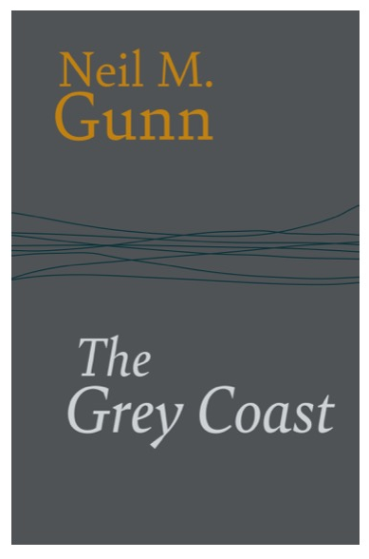

North House Press, The Grey House, Dalreavoch, IV28 3YF Telephone +44 (0)7768994332, Email: david@northhousepress.co.uk www. northhousepress.com

